F14076083 魏湧致

6.20

(a) z = $\frac{9.5-8}{0.9}$ ≈ 1.67 P(X>9.5) = P(Z>1.67) = 1- P(Z<1.67) = 1-0.9525 = 0.0475

(b) z = $\frac{8.6-8}{0.9}$ ≈ 0.67 P(X≤8.6) = P(Z≤0.67) = 0.7486

(c) z1 = ≈ -0.78 z2 = ≈ 1.22

P(7.3<X<9.1) = P(-0.78<Z<1.22) = P(Z<1.22)-P(Z<-0.78)

=0.8888-0.2177 = 0.6711

6.28

μ = np = 100*0.72 = 72 σ = $\sqrt{npq}$ = $\sqrt{100*0.72*0.28}$ ≈ 4.49

1. z = $\frac{79.5-72}{4.49}$ ≈ 1.67 P(X≥80) = P(Z≥1.67) = 1- P(Z<1.67) = 1-0.9525 = 0.0475
2. z = $\frac{68.5-72}{4.49}$ ≈ -0.78 P(X≤68) = P(Z≤-0.78) = 0.2177

6.58

(a) Poisson distribution mean μ=5 P(X>10) = 1-P(X≤10) = 1-0.9863 = 0.0137

(b) gamma distribution mean β=1/5 α=10

P(X>2) = 1-P(X≤2) = 1- $\int_{0}^{2}{\frac{5^{10}}{9!}x^{9}e^{-5x}}dx$ = 1- $\int_{0}^{10}{\frac{y^{9}e^{-y}}{9!}}dy$

= 1-0.5421 = 0.4579

**Matlab**

1.a

Distribution 1: 𝜇x, 𝜎x, 𝜇y, 𝜎y, 𝜌 = [50, 20, 1500, 200, 0]

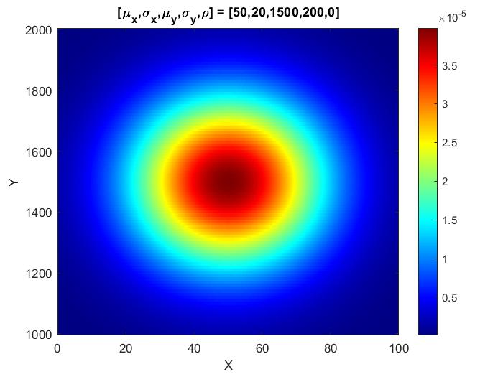

Distribution 2: 𝜇x, 𝜎x, 𝜇y, 𝜎y, 𝜌 = [50, 20, 1500, 200, 0.3]

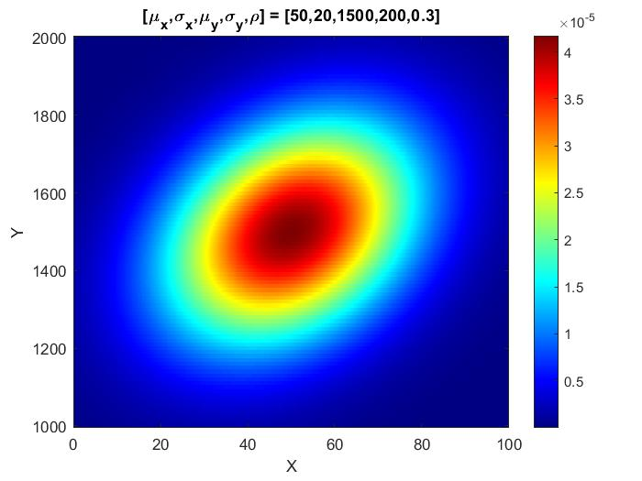

Distribution 3: 𝜇x, 𝜎x, 𝜇y, 𝜎y, 𝜌 = [50, 20, 1500, 200, 0.8]

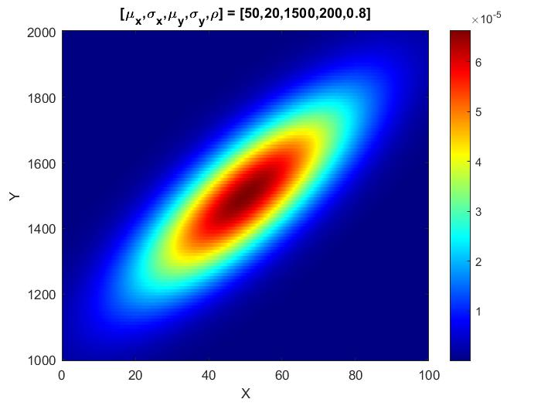

Distribution 4: 𝜇x, 𝜎x, 𝜇y, 𝜎y, 𝜌 = [50, 20, 1500, 200,−0.8]

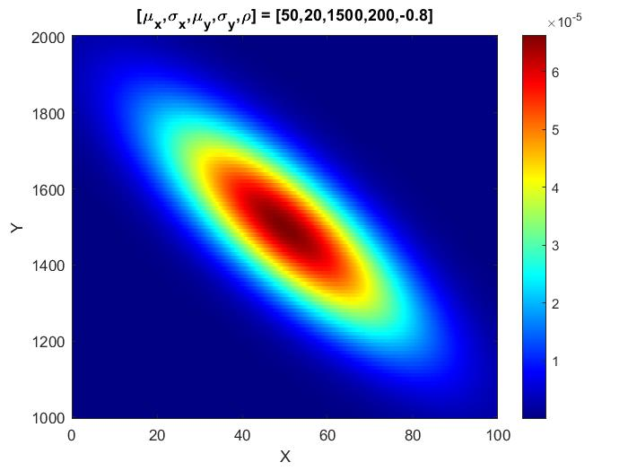

1.b

𝜌為0時圖形以同心圓往外逐漸遞減，當𝜌越來越大時，圖形會呈現左下右上的橢圓且會越來越扁，而𝜌改為負數時會是將原本正數𝜌的圖形左右對稱。

2.a

Case1:

Distribution 1: 𝜇x, 𝜎x, 𝜇y, 𝜎y, 𝜌 = [25, 30, 1250, 300, 0]

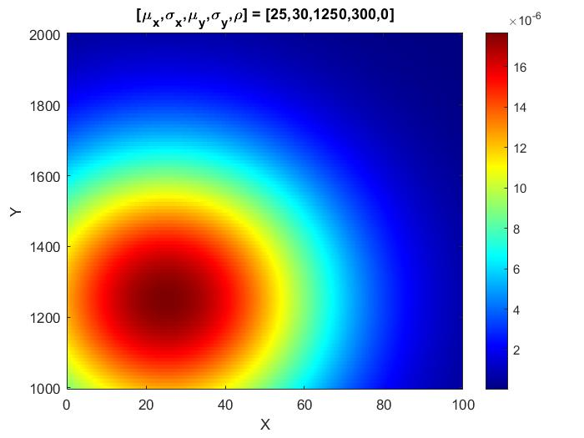

Distribution 2: 𝜇x, 𝜎x, 𝜇y, 𝜎y, 𝜌 = [75, 30, 1750, 300, 0]

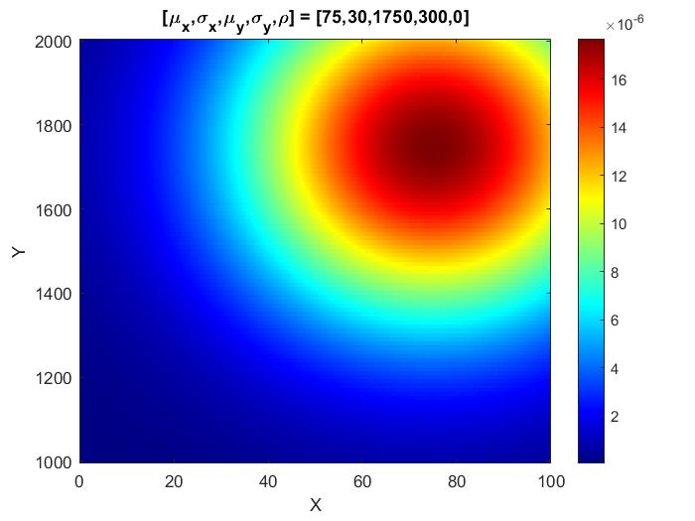

Decision boundary:

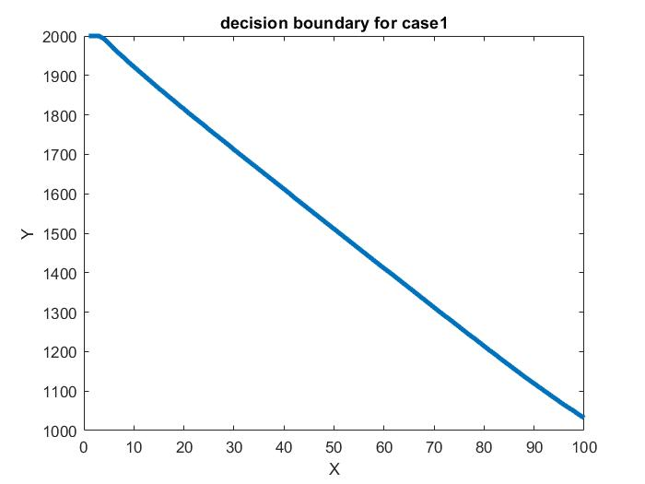

Case2

Distribution 1: 𝜇x, 𝜎x, 𝜇y, 𝜎y, 𝜌 = [25, 20, 1250, 200, 0]

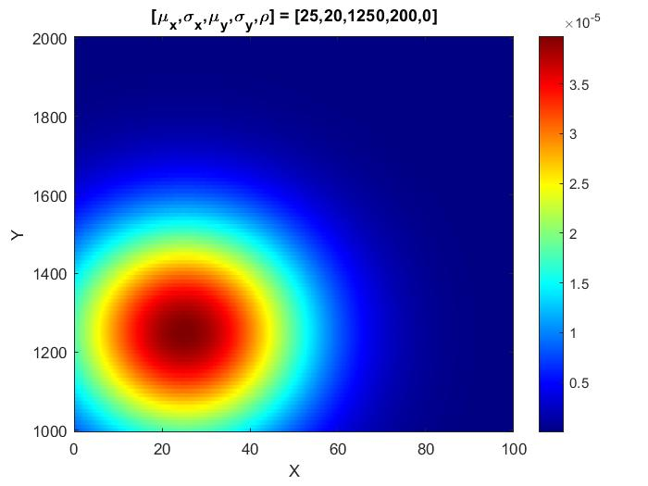

Distribution 2: 𝜇x, 𝜎x, 𝜇y, 𝜎y, 𝜌 = [75, 30, 1750, 300, 0]



Decision boundary:

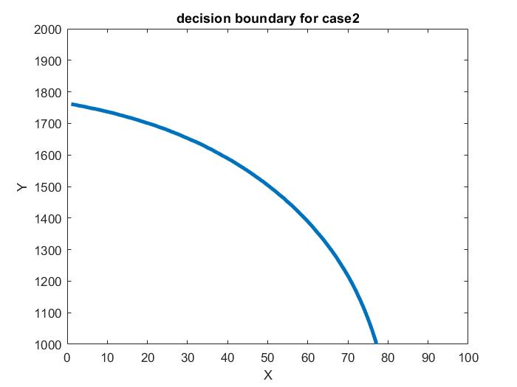

2.b

Case1的兩個distribution只有平均值有改變且是對稱的，固圖形也相互對稱，所以decision boundary大約為左上到右下的斜直線。而Case2的兩個distribution不只有平均值改變，標準差也有變動，且distribution1的標準差比distribution2還要小，所以同心圓較小，故decision boundary是將distribution1包住的弧形。